**Muhammad Sana Ullah**

**BSSE-6435**

**DSA Lab - Assignment-1 → Queues**

**Question-1:**

**#include <iostream>**

**#include <queue>**

**using namespace std;**

**#define MAX_SIZE 10**

**int main(){**

**queue<int> values;**

**int num , minValue , maxValue ;**

**cout << "Enter " << MAX_SIZE << " Stack Values: " ;**

**for (int i = 0; i < MAX_SIZE; i++){**

**cin >> num ;**

**values.push(num);**

**}**

**minValue = maxValue = values.front();**

**while (!values.empty()){**

**int element = values.front();**

**values.pop();**

**if(element>maxValue){**

**maxValue = element ;**

**}**

**if(element<minValue){**

**minValue = element ;**

**}**

**}**

**cout << "Max_Value is: " << maxValue << endl;**

**cout << "Min_Value is: " << minValue << endl;**

**return 0;**

**}**

**Output**

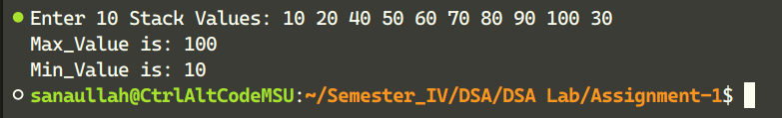

**Question-2:**

**#include <iostream>**

**#include <queue>**

**using namespace std;s**

**#define MAX_SIZE 10**

**int main(){**

**priority_queue<string> nameQueue ;**

**string name ;**

**cout << "Enter " << MAX_SIZE << " Names: " ;**

**for(int i = 0 ; i < MAX_SIZE ; i++){**

**cin >> name ;s**

**nameQueue.push(name);**

**}**

**string topPriority = nameQueue.top();**

**cout << "Name with top Priority: " ;**

**while(!nameQueue.empty() && nameQueue.top() == topPriority){**

**cout << nameQueue.top() << endl;**

**nameQueue.pop();**

**}**

**return 0;**

**}**

**Output**

